Google 大模型调用指南
本指南旨在指导如何通过 Google Vertex AI 平台调用 Gemini 等大模型。Vertex AI 提供企业级的安全性、可扩展性和管理功能，适用于生产环境。

1. Gemini系列模型

1.1 调用方式
调用 Vertex AI API 主要有两种认证方式：直接 API Key 调用（适用于简单测试）和 服务账号 (Service Account) 密钥调用（推荐生产环境使用）。

1.1.1 REST 方式调用 (快速开始)
适用场景：快速原型开发、轻量级应用、个人项目

1.1.1.1 获取API key
- 访问Google Vertex AI平台：https://console.cloud.google.com/vertex-ai/studio，左上角选择你的project，初次访问需要启用API：
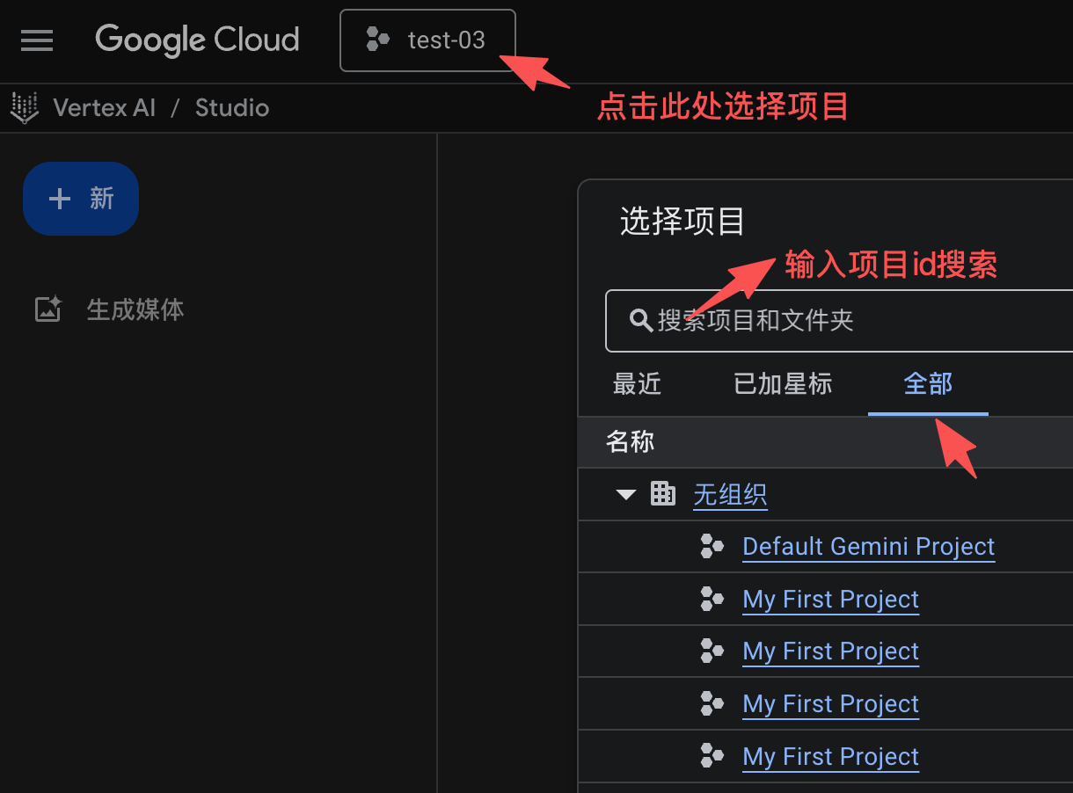 | 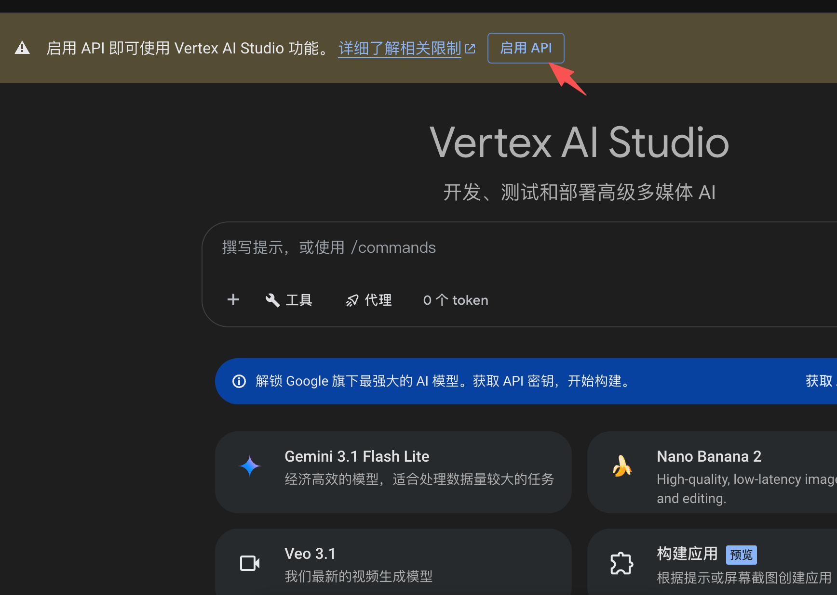
- 点击左下角获取API密钥，跳转后点击创建API密钥：（请妥善保管你的Key！）
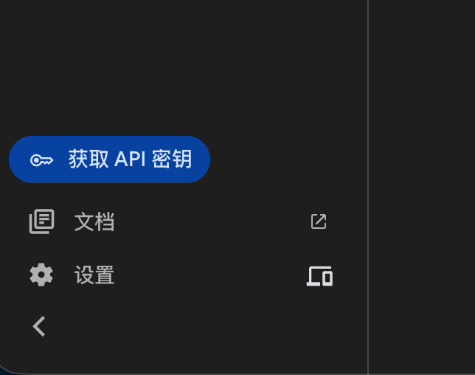 | 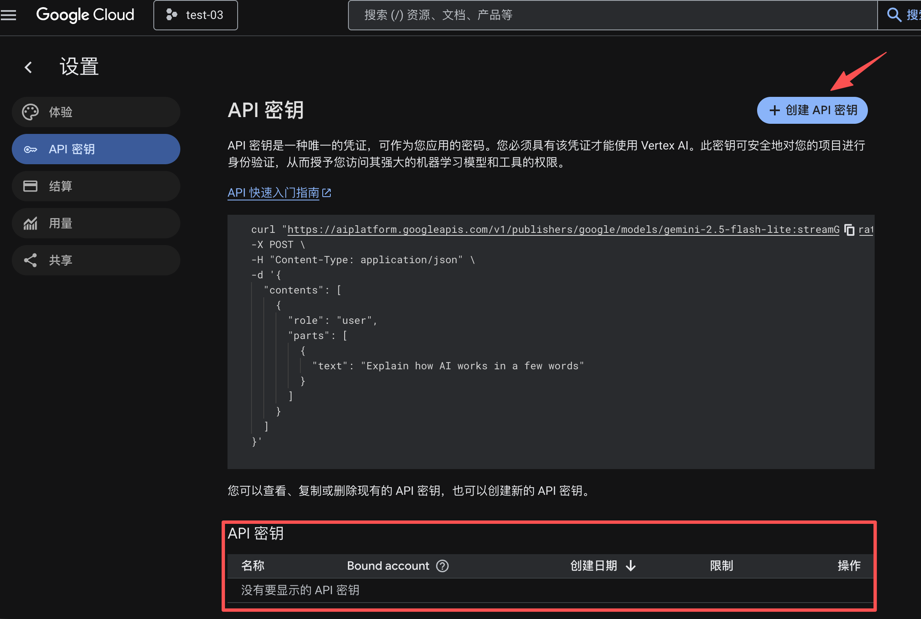

1.1.1.2 调用API
- 示例代码 1
访问模型 global 端点

Shell
MODEL_ID="gemini-2.5-flash-lite"
curl "https://aiplatform.googleapis.com/v1/publishers/google/models/${MODEL_ID}:generateContent?key=${API_KEY}" \
-X POST \
-H "Content-Type: application/json" \
-d '{
"contents": [
{
"role": "user",
"parts": [
{
"text": "Explain how AI works in a few words"
}
]
}
]
}'
- 示例代码 2
访问模型区域端点，是否可以使用区域端点需要模型本身支持，详细请查看模型介绍中区域部分：
https://docs.cloud.google.com/vertex-ai/generative-ai/docs/models?hl=zh-cn

Shell
MODEL_ID="gemini-2.5-flash-lite"
LOCATION_ID="us-central1"
curl "https://${LOCATION_ID}-aiplatform.googleapis.com/v1/publishers/google/models/${MODEL_ID}:generateContent?key=${API_KEY}" \
-X POST \
-H "Content-Type: application/json" \
-d '{
"contents": [
{
"role": "user",
"parts": [
{
"text": "Explain how AI works in a few words"
}
]
}
]
}'

更多请求参数和响应参数说明请参考：https://docs.cloud.google.com/vertex-ai/generative-ai/docs/model-reference/inference?hl=zh-CN

1.1.2 Gen AI SDK 调用
更多SDK说明请参考官网说明文档：https://docs.cloud.google.com/vertex-ai/generative-ai/docs/sdks/overview?hl=zh-CN

1.1.2.1 使用服务账号密钥认证
服务账号是 Google Cloud 标准的认证方式，通过 JSON 密钥文件进行身份验证，更安全且支持更广泛的模型。

1.1.2.1.1 创建并配置 Service Account

1.1.2.1.2 登录 GCP 控制台
https://console.cloud.google.com/（请使用授权的 Google 账号，不清楚可咨询销售经理）

1.1.2.1.3 选择分配的project
（不清楚的可咨询销售经理获取）
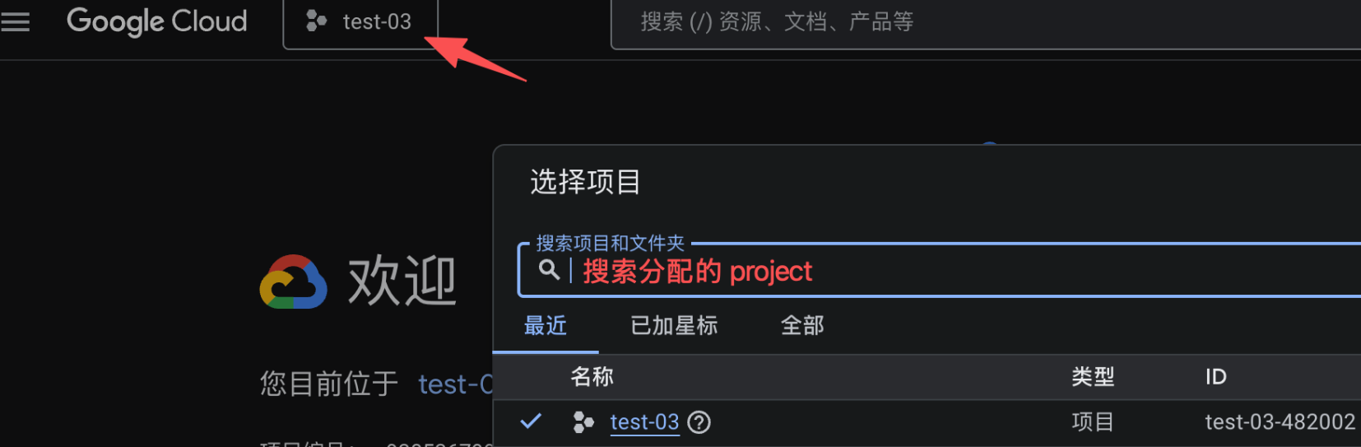

1.1.2.1.4 创建服务账号
进入服务账号界面（IAM 和管理），点击创建：
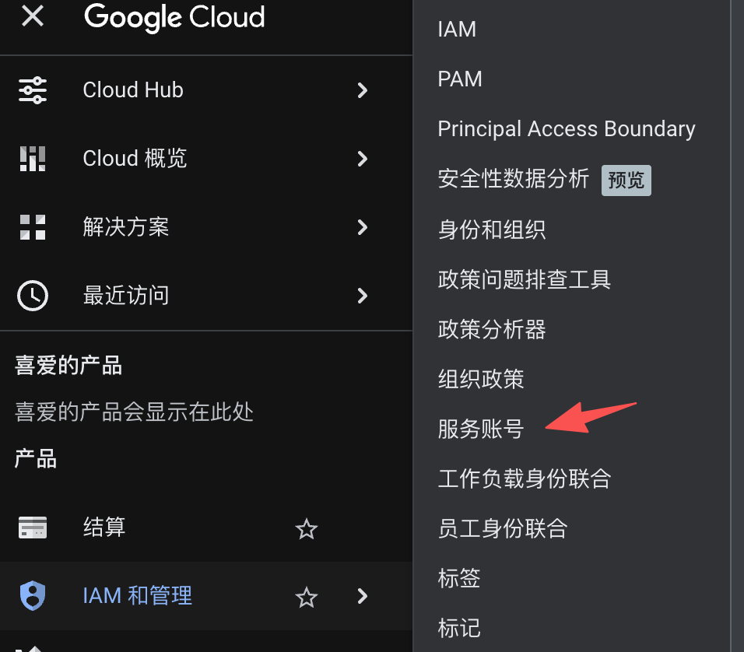 | 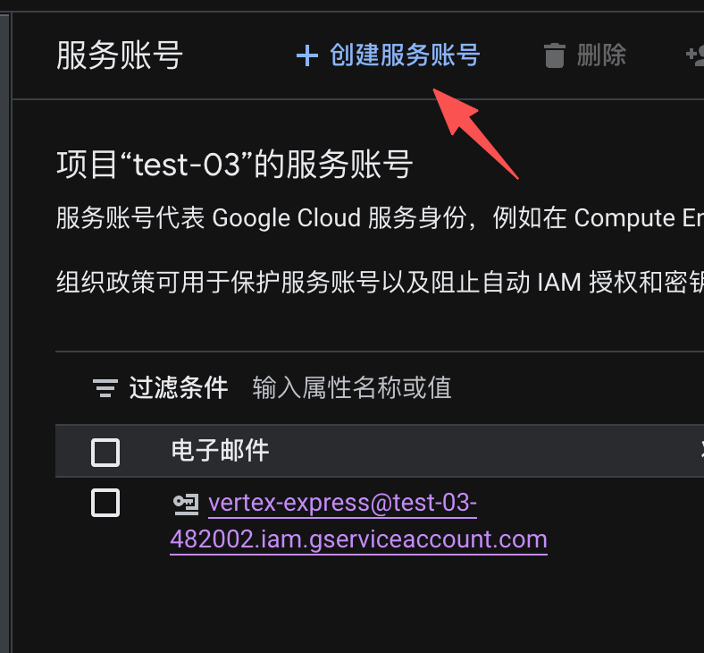

1.1.2.1.5 配置服务账号
服务账号 ID 自定义，权限给 Vertex AI User
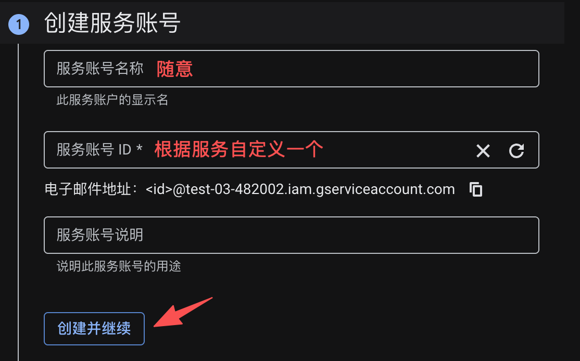 | 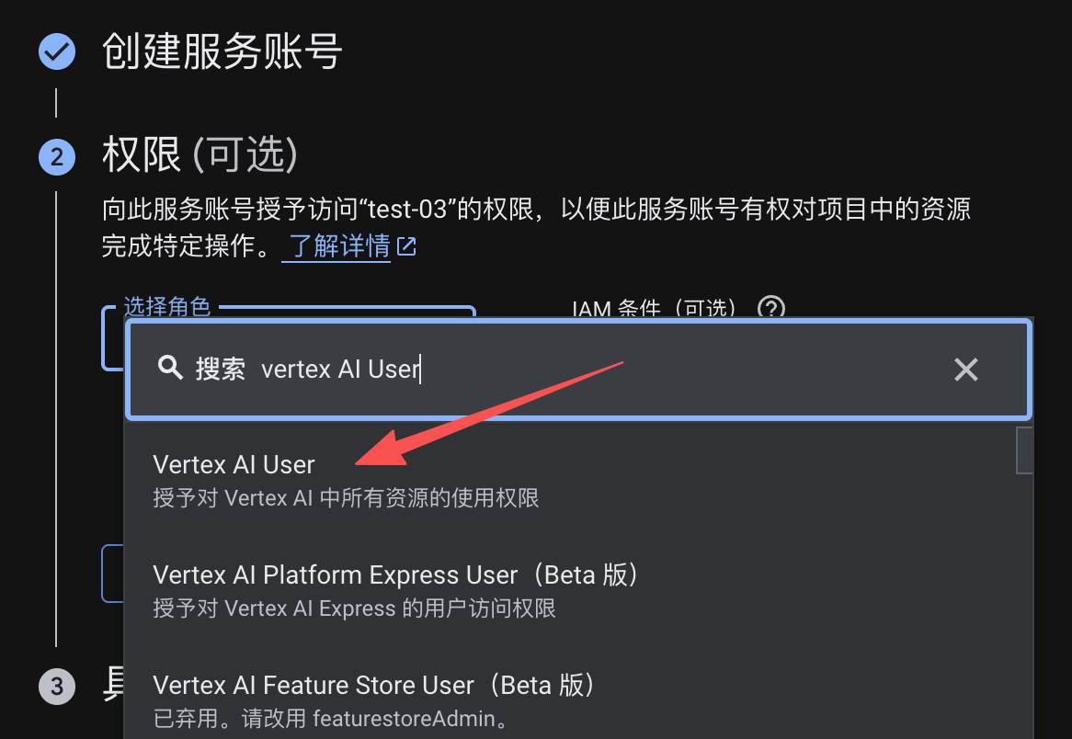

1.1.2.1.6 创建服务账号密钥
点击创建的服务账号进入：
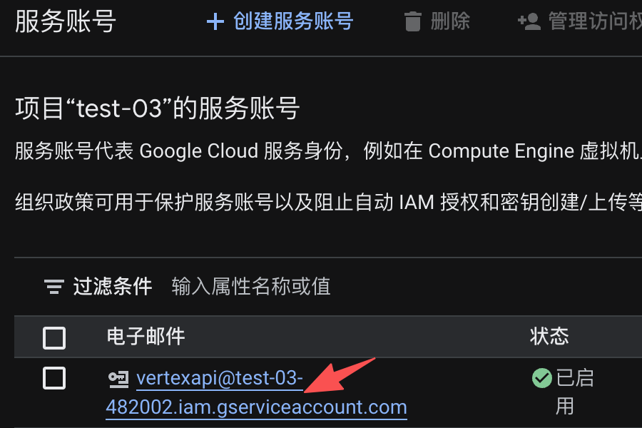 | 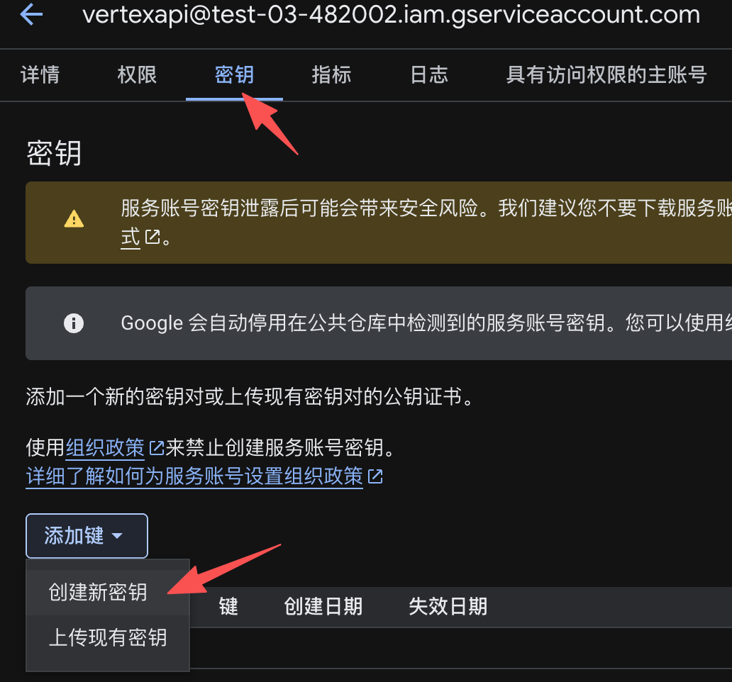

1.1.2.1.7 获取密钥文件（JSON）
点击创建后会跳出下载 json 界面，请妥善保管自己的密钥文件！
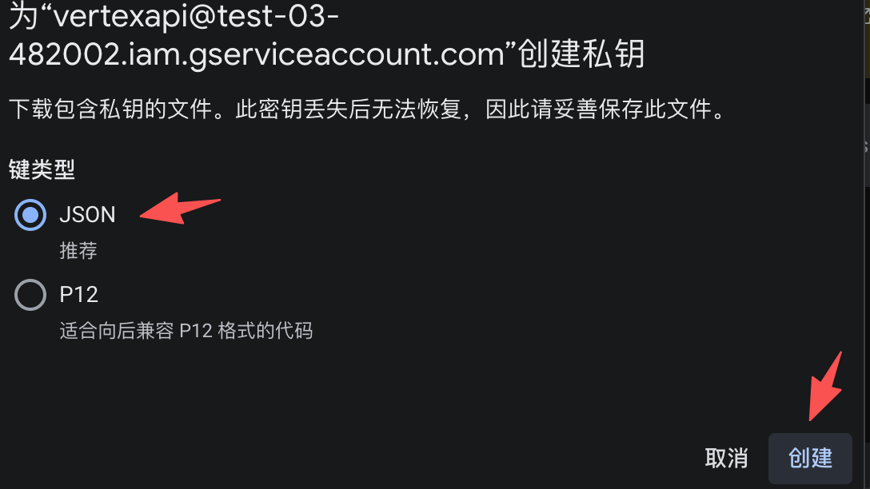 | 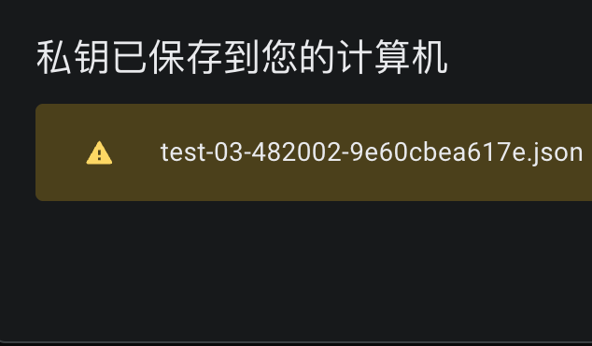

1.1.2.1.8 Python 示例代码
Plain Text
pip install --upgrade google-genai

Shell
非流式返回
from google import genai
from google.oauth2 import service_account
# 定义服务账号 JSON 文件的路径
credentials_path = 'your-json-file-path'
# 手动加载服务账号凭据，并指定必要的 Scope
scopes = ['https://www.googleapis.com/auth/cloud-platform']
credentials = service_account.Credentials.from_service_account_file(
credentials_path,
scopes=scopes
)
# 初始化客户端，显式传入凭据
client = genai.Client(
vertexai=True,
project='your-project-id',
location='global', # 或者其他区域端点，详细请查看模型说明支持的 region
credentials=credentials
)
response = client.models.generate_content(
model='gemini-2.0-flash',
contents='你是谁?'
)
print(response.text)

1.2 进阶配置

1.2.1 OpenAI 兼容调用

1.2.1.1 Chat Completions API 调用
在使用 OpenAI 兼容模式时，需要注意：
- Base URL：需要指向 Vertex AI 的兼容端点。
- Model 名称：需要添加 google/ 前缀，例如 google/gemini-2.0-flash-exp。
- 认证：仍需使用 Service Account 认证，但可以在 Header 中传递 Bearer Token。
OpenAI 库兼容性调用说明文档
https://docs.cloud.google.com/vertex-ai/generative-ai/docs/start/openai?hl=zh-cn#thinking

Python 示例代码
使用服务账号认证获取 token
服务账号的获取参考 1.1.2.1 章节

Python
非流式返回
import openai
from google.auth import default
from google.oauth2 import service_account
from google.auth.transport.requests import Request
project_id="your-project-id"
# 定义服务账号 JSON 文件的路径
credentials_path = 'your-json-file-path'
# 手动加载服务账号凭据，并指定必要的 Scope
scopes = ['https://www.googleapis.com/auth/cloud-platform']
credentials = service_account.Credentials.from_service_account_file(
credentials_path,
scopes=scopes
)
auth_request = Request()
credentials.refresh(auth_request)
location_id="global"
# 2. 配置 OpenAI 客户端
client = openai.OpenAI(
base_url="https://aiplatform.googleapis.com/v1/projects/{0}/locations/{1}/endpoints/openapi/".format(project_id, location_id),
api_key=credentials.token, # 使用 OAuth Token 作为 Bearer Token
)
# 3. 发起请求
response = client.chat.completions.create(
model="google/gemini-2.5-flash", # 注意加上 google/ 前缀
messages=[
{"role": "user", "content": "介绍一下你自己"}
],
temperature=0.7,
)
print(response)
如果需要使用区域端点访问模型，请参考以下代码：
Python
location_id="us-central1"
# 2. 配置 OpenAI 客户端
client = openai.OpenAI(
base_url="https://{0}-aiplatform.googleapis.com/v1/projects/{1}/locations/{2}/endpoints/openapi/".format(location_id, project_id, location_id),
api_key=credentials.token, # 使用 OAuth Token 作为 Bearer Token
)

Python
流式返回
# 其他代码和流式返回一样
response = client.chat.completions.create(
model="google/gemini-2.5-flash", # 注意加上 google/ 前缀
messages=[
{"role": "user", "content": "介绍一下你自己"}
],
temperature=0.7,
stream=True
)
for chunk in response:
print(chunk)

1.2.2 流式返回（Streaming）
流式返回可以降低首字延迟，提升用户体验。Vertex AI 支持两种流式模式：标准流和 Server-Sent Events (SSE)。

1.2.2.1 使用 genai SDK
- Python 示例代码
Python
from google import genai
from google.oauth2 import service_account
# 定义服务账号 JSON 文件的路径
credentials_path = 'your-json-file-path'
# 手动加载服务账号凭据，并指定必要的 Scope
scopes = ['https://www.googleapis.com/auth/cloud-platform']
credentials = service_account.Credentials.from_service_account_file(
credentials_path,
scopes=scopes
)
# 初始化客户端，显式传入凭据
client = genai.Client(
vertexai=True,
project='your-project-id',
location='global', # 或者其他区域端点，详细请查看模型说明支持的 region
credentials=credentials
)
# 流式生成
response = client.models.generate_content_stream(
model="gemini-2.0-flash-exp",
contents="Write a story about a robot learning to paint."
)
# 逐块打印
for chunk in response:
# 每个 chunk 包含增量文本
print(chunk.text, end="", flush=True)

1.2.2.2 使用 REST

1.2.2.2.1 标准流式返回
流式端点需要使用 streamGenerateContent 后缀
- 示例代码
Bash
curl "https://aiplatform.googleapis.com/v1/publishers/google/models/gemini-2.5-flash-lite:streamGenerateContent?&key=${API_KEY}" \
-X POST \
-H "Content-Type: application/json" \
-d '{
"contents": [
{
"role": "user",
"parts": [
{
"text": "你好"
}
]
}
]
}'
- 响应示例（流式 JSON 数组）：
JSON
[{
"candidates": [
{
"content": {
"role": "model",
"parts": [
{
"text": "你好"
}
]
}
}
],
"usageMetadata": {
"trafficType": "ON_DEMAND"
},
"modelVersion": "gemini-2.5-flash-lite",
"createTime": "2026-03-26T09:47:08.970069Z",
"responseId": "nADFadWaO7W8vPEP08msiAg"
}
,
{
"candidates": [
{
"content": {
"role": "model",
"parts": [
{
"text": "！有什么"
}
]
}
}
],
"usageMetadata": {
"trafficType": "ON_DEMAND"
},
"modelVersion": "gemini-2.5-flash-lite",
"createTime": "2026-03-26T09:47:08.970069Z",
"responseId": "nADFadWaO7W8vPEP08msiAg"
}
,
{
"candidates": [
{
"content": {
"role": "model",
"parts": [
{
"text": "可以帮到你的吗？"
}
]
},
"finishReason": "STOP"
}
],
"usageMetadata": {
"promptTokenCount": 1,
"candidatesTokenCount": 9,
"totalTokenCount": 10,
"trafficType": "ON_DEMAND",
"promptTokensDetails": [
{
"modality": "TEXT",
"tokenCount": 1
}
],
"candidatesTokensDetails": [
{
"modality": "TEXT",
"tokenCount": 9
}
]
},
"modelVersion": "gemini-2.5-flash-lite",
"createTime": "2026-03-26T09:47:08.970069Z",
"responseId": "nADFadWaO7W8vPEP08msiAg"
}
]

1.2.2.2.2 SSE 格式流式返回
流式端点需要使用 streamGenerateContent 后缀，并且在 base_url中增加 alt=sse 参数：
- 示例代码：
JSON
curl "https://aiplatform.googleapis.com/v1/publishers/google/models/gemini-2.5-flash-lite:streamGenerateContent?alt=sse&key=${API_KEY}" \
-X POST \
-H "Content-Type: application/json" \
-d '{
"contents": [
{
"role": "user",
"parts": [
{
"text": "介绍一下你自己"
}
]
}
]
}'
- 响应示例
JSON
data: {"candidates": [{"content": {"role": "model","parts": [{"text": "您"}]}}],"usageMetadata": {"trafficType": "ON_DEMAND"},"modelVersion": "gemini-2.5-flash-lite","createTime": "2026-03-26T09:39:00.264302Z","responseId": "tP7Eae6QEI6MqsMP55LW4Qc"}
data: {"candidates": [{"content": {"role": "model","parts": [{"text": "好！很高"}]}}],"usageMetadata": {"trafficType": "ON_DEMAND"},"modelVersion": "gemini-2.5-flash-lite","createTime": "2026-03-26T09:39:00.264302Z","responseId": "tP7Eae6QEI6MqsMP55LW4Qc"}
data: {"candidates": [{"content": {"role": "model","parts": [{"text": "兴能和您交流。\n\n我是一个大型语言模型，由 Google 训练。"}]}}],"usageMetadata": {"trafficType": "ON_DEMAND"},"modelVersion": "gemini-2.5-flash-lite","createTime": "2026-03-26T09:39:00.264302Z","responseId": "tP7Eae6QEI6MqsMP55LW4Qc"}
data: {"candidates": [{"content": {"role": "model","parts": [{"text": "\n\n我的主要目的是：\n\n* **理解和生成人类语言：** 我能够理解"}]}}],"usageMetadata": {"trafficType": "ON_DEMAND"},"modelVersion": "gemini-2.5-flash-lite","createTime": "2026-03-26T09:39:00.264302Z","responseId": "tP7Eae6QEI6MqsMP55LW4Qc"}
data: {"candidates": [{"content": {"role": "model","parts": [{"text": "您提出的问题、指令或陈述，并用自然、连贯的语言来回应。\n* **提供信息和知识：** 我拥有庞"}]}}],"usageMetadata": {"trafficType": "ON_DEMAND"},"modelVersion": "gemini-2.5-flash-lite","createTime": "2026-03-26T09:39:00.264302Z","responseId": "tP7Eae6QEI6MqsMP55LW4Qc"}
data: {"candidates": [{"content": {"role": "model","parts": [{"text": "大的知识库，可以回答各种各样的问题，涵盖历史、科学、文化、技术等等。\n* **进行创意写作：** 我可以帮助"}]}}],"usageMetadata": {"trafficType": "ON_DEMAND"},"modelVersion": "gemini-2.5-flash-lite","createTime": "2026-03-26T09:39:00.264302Z","responseId": "tP7Eae6QEI6MqsMP55LW4Qc"}
data: {"candidates": [{"content": {"role": "model","parts": [{"text": "您创作故事、诗歌、代码、剧本、电子邮件、信件等多种文本格式。\n* **翻译语言：** 我能够进行多种语言之间的翻译。\n* **总结文本：** 我可以帮助您快速"}]}}],"usageMetadata": {"trafficType": "ON_DEMAND"},"modelVersion": "gemini-2.5-flash-lite","createTime": "2026-03-26T09:39:00.264302Z","responseId": "tP7Eae6QEI6MqsMP55LW4Qc"}
data: {"candidates": [{"content": {"role": "model","parts": [{"text": "理解长篇文档的要点。\n* **辅助学习和研究：** 我可以为您提供解释、背景信息，并帮助您探索新的话题。\n\n**我没有：**\n\n* **个人身份或意识"}]}}],"usageMetadata": {"trafficType": "ON_DEMAND"},"modelVersion": "gemini-2.5-flash-lite","createTime": "2026-03-26T09:39:00.264302Z","responseId": "tP7Eae6QEI6MqsMP55LW4Qc"}
data: {"candidates": [{"content": {"role": "model","parts": [{"text": "：** 我没有名字、情感、经历或个人观点。我是一个人工智能程序。\n* **物理身体：** 我存在于数字世界中。\n* **自主行动的能力：** 我只能根据您的输入和指令来做出反应。\n\n**您可以把我当作一个强大的工具，一个知识"}]}}],"usageMetadata": {"trafficType": "ON_DEMAND"},"modelVersion": "gemini-2.5-flash-lite","createTime": "2026-03-26T09:39:00.264302Z","responseId": "tP7Eae6QEI6MqsMP55LW4Qc"}
data: {"candidates": [{"content": {"role": "model","parts": [{"text": "的助手，或者一个创意伙伴。**\n\n您可以问我任何您想知道的，或者让我帮您做任何与文本相关的事情。我在这里为您服务，并尽力满足您的需求。\n\n**您有什么想问我的吗？或者有什么我可以帮您的吗？**"}]},"finishReason": "STOP"}],"usageMetadata": {"promptTokenCount": 3,"candidatesTokenCount": 328,"totalTokenCount": 331,"trafficType": "ON_DEMAND","promptTokensDetails": [{"modality": "TEXT","tokenCount": 3}],"candidatesTokensDetails": [{"modality": "TEXT","tokenCount": 328}]},"modelVersion": "gemini-2.5-flash-lite","createTime": "2026-03-26T09:39:00.264302Z","responseId": "tP7Eae6QEI6MqsMP55LW4Qc"}

1.3 Batch API 调用
Batch API 适用于不需要实时响应的离线任务（如数据清洗、大批量分类），成本通常低于实时 API 。
- 输入数据格式
将请求数据存储在 GCS 的 JSONL 文件中（每行一个请求）。
输入文件 input.jsonl 示例：
JSON
{"content": "Classify sentiment: I love this product!", "mimeType": "text/plain"}
{"content": "Classify sentiment: This is terrible.", "mimeType": "text/plain"}
- 使用 Python SDK 提交任务
Python
from google.cloud import aiplatform
# 初始化
aiplatform.init(project='your-project', location='us-central1')
# 创建批量预测任务
batch_prediction_job = aiplatform.BatchPredictionJob.create(
model_name='projects/your-project/locations/us-central1/models/gemini-1.5-pro',
job_display_name='my-batch-job',
gcs_source='gs://your-bucket/input.jsonl',
gcs_destination_prefix='gs://your-bucket/output/',
machine_type='n1-standard-4',
starting_replica_count=1,
max_replica_count=5,
)
# 等待任务完成
batch_prediction_job.wait()
# 查看输出路径
print(f"Output location: {batch_prediction_job.gcs_output_directory}")

2. Imagen模型
Imagen API 支持以下模型：
- imagen-4.0-generate-001
- imagen-4.0-fast-generate-001
- imagen-4.0-ultra-generate-001
- imagen-3.0-generate-002
- imagen-3.0-generate-001
- imagen-3.0-fast-generate-001
- imagen-3.0-capability-001

2.1 生成图片调用方式

2.1.1 REST 方式调用
Python
"""
使用 REST API 调用 Vertex AI Imagen 模型生成图片
端点: https://{LOCATION}-aiplatform.googleapis.com/v1/projects/{PROJECT_ID}/locations/{LOCATION}/publishers/google/models/{MODEL}:predict
认证方式:
1. API Key (通过 x-goog-api-key header)
2. Access Token (通过 Authorization: Bearer header)
参考文档: https://docs.cloud.google.com/vertex-ai/generative-ai/docs/model-reference/imagen-api
"""
import os
import base64
import requests
def build_url(project_id: str, location: str, model: str) -> str:
"""构建 Vertex AI Imagen REST 端点 URL"""
return (
f"https://{location}-aiplatform.googleapis.com/v1/"
f"projects/{project_id}/locations/{location}/"
f"publishers/google/models/{model}:predict"
)
def generate_image(
project_id: str,
location: str = "us-central1",
model: str = "imagen-4.0-generate-001",
prompt: str = "",
output_path: str = "output.png",
sample_count: int = 1,
aspect_ratio: str | None = None,
negative_prompt: str | None = None,
api_key: str | None = None,
access_token: str | None = None,
) -> None:
"""通过 Vertex AI REST API 调用 Imagen 生成图片
Args:
api_key: 使用 API Key 认证 (x-goog-api-key)
access_token: 使用 Access Token 认证 (Bearer token)
二者传其一即可，api_key 优先
"""
url = build_url(project_id, location, model)
# 构建认证 header
headers = {"Content-Type": "application/json"}
if api_key:
headers["x-goog-api-key"] = api_key
elif access_token:
headers["Authorization"] = f"Bearer {access_token}"
else:
raise ValueError("必须提供 api_key 或 access_token")
# 构建请求体 (严格按照官方文档格式)
parameters: dict = {
"sampleCount": sample_count,
}
if aspect_ratio:
parameters["aspectRatio"] = aspect_ratio
if negative_prompt:
parameters["negativePrompt"] = negative_prompt
payload = {
"instances": [{"prompt": prompt}],
"parameters": parameters,
}
print(f"正在调用 Imagen 模型: {model}")
print(f"端点: {url}")
resp = requests.post(url, json=payload, headers=headers, timeout=120)
if resp.status_code != 200:
print(f"请求失败 [{resp.status_code}]: {resp.text}")
return
data = resp.json()
predictions = data.get("predictions", [])
if not predictions:
print("未生成图片，可能触发了安全过滤。")
return
for i, prediction in enumerate(predictions):
if "bytesBase64Encoded" not in prediction:
reason = prediction.get("raiFilteredReason", "未知原因")
print(f"第 {i} 张图片被过滤: {reason}")
continue
image_bytes = base64.b64decode(prediction["bytesBase64Encoded"])
mime_type = prediction.get("mimeType", "image/png")
ext = "jpg" if "jpeg" in mime_type else "png"
if sample_count == 1:
path = output_path
else:
base_name = output_path.rsplit(".", 1)[0]
path = f"{base_name}_{i}.{ext}"
with open(path, "wb") as f:
f.write(image_bytes)
print(f"图片已保存: {path}")
if __name__ == "__main__":
generate_image(
project_id="your-project-id",
location="your-location",
api_key="your-vertex-api-key",
prompt="一只在海边奔跑的金毛犬，夕阳西下，电影感画面",
output_path="output_rest.png",
sample_count=1,
aspect_ratio="16:9",
)

2.1.2 Gen AI SDK 调用
Python
"""
使用 google-genai SDK 调用 Imagen 模型生成图片
通过 Service Account 进行身份认证（Vertex AI）
参考文档:
- https://docs.cloud.google.com/vertex-ai/generative-ai/docs/model-reference/imagen-api
- https://cloud.google.com/vertex-ai/generative-ai/docs/image/generate-images
"""
import os
from google import genai
from google.genai import types
from google.oauth2.service_account import Credentials
def create_client(
service_account_path: str,
project_id: str,
location: str = "us-central1",
) -> genai.Client:
"""使用 Service Account 创建 genai Client"""
scopes = ["https://www.googleapis.com/auth/cloud-platform"]
credentials = Credentials.from_service_account_file(
service_account_path, scopes=scopes
)
return genai.Client(
vertexai=True,
project=project_id,
location=location,
credentials=credentials,
)
def generate_image(
client: genai.Client,
prompt: str,
output_path: str = "output.png",
model: str = "imagen-4.0-generate-001",
number_of_images: int = 1,
language: str = "auto",
aspect_ratio: str = "1:1",
safety_filter_level: str = "block_some",
person_generation: str = "allow_adult",
add_watermark: bool = True,
seed: int | None = None,
negative_prompt: str | None = None,
output_mime_type: str = "image/png",
enhance_prompt: bool = False,
) -> None:
"""调用 Imagen 模型生成图片并保存到本地
Args:
prompt: 图片的文本提示
model: Imagen 模型版本
number_of_images: 生成图片数量 (1-4)
language: 提示语言 ("auto", "en", "zh", "zh-TW", "ja", "ko", "hi", "es", "pt")
aspect_ratio: 宽高比 ("1:1", "3:4", "4:3", "9:16", "16:9")
safety_filter_level: 安全过滤级别 ("block_low_and_above", "block_medium_and_above", "block_only_high")
person_generation: 人物生成策略 ("dont_allow", "allow_adult", "allow_all")
add_watermark: 是否添加不可见水印 (与 seed 互斥)
seed: 随机种子，用于可复现生成 (与 add_watermark 互斥)
negative_prompt: 反向提示，描述不希望出现的内容 (imagen-3.0-generate-002+ 不支持)
output_mime_type: 输出格式 ("image/png" 或 "image/jpeg")
enhance_prompt: 是否启用提示增强 (默认关闭，避免 LLM 改写导致偏离原意)
"""
config = types.GenerateImagesConfig(
number_of_images=number_of_images,
language=language,
aspect_ratio=aspect_ratio,
safety_filter_level=safety_filter_level,
person_generation=person_generation,
include_rai_reason=True,
output_mime_type=output_mime_type,
enhance_prompt=enhance_prompt,
)
# seed 和 add_watermark 互斥
if seed is not None:
config.seed = seed
config.add_watermark = False
else:
config.add_watermark = add_watermark
if negative_prompt:
config.negative_prompt = negative_prompt
response = client.models.generate_images(
model=model,
prompt=prompt,
config=config,
)
print(f"模型: {model}")
print(f"Prompt: {prompt}")
print(f"enhance_prompt: {enhance_prompt}")
if not response.generated_images:
print("未生成图片，可能触发了安全过滤。")
return
ext = "jpg" if "jpeg" in output_mime_type else "png"
for i, generated_image in enumerate(response.generated_images):
if number_of_images == 1:
path = output_path
else:
base_name = output_path.rsplit(".", 1)[0]
path = f"{base_name}_{i}.{ext}"
generated_image.image.save(path)
print(f"图片已保存: {path} ({len(generated_image.image.image_bytes)} bytes)")
if __name__ == "__main__":
sa_path = "your-json-file-path"
project = "your-project-id"
location = "your-location"
client = create_client(sa_path, project, location)
generate_image(
client=client,
prompt="A golden retriever running on the beach at sunset, cinematic lighting, photorealistic",
output_path="output.png",
model="imagen-3.0-generate-002",
number_of_images=1,
language="en",
aspect_ratio="16:9",
safety_filter_level="block_medium_and_above",
person_generation="allow_adult",
enhance_prompt=False,
)

2.2 修改图片调用方式
Python
"""
使用 REST API 调用 Vertex AI Imagen 修改图片
模型: imagen-3.0-capability-001
支持的编辑模式:
- EDIT_MODE_INPAINT_REMOVAL: 移除蒙版区域中的对象，填充背景
- EDIT_MODE_INPAINT_INSERTION: 在蒙版区域中插入新对象
- EDIT_MODE_BGSWAP: 替换背景，保留前景对象
- EDIT_MODE_OUTPAINT: 向外扩展图片内容
蒙版模式:
- MASK_MODE_USER_PROVIDED: 用户提供黑白蒙版图片
- MASK_MODE_BACKGROUND: 自动分割背景作为蒙版
- MASK_MODE_FOREGROUND: 自动分割前景作为蒙版
- MASK_MODE_SEMANTIC: 按语义类别自动生成蒙版
参考文档: https://docs.cloud.google.com/vertex-ai/generative-ai/docs/model-reference/imagen-api-edit
"""
import os
import base64
import requests
def build_url(project_id: str, location: str) -> str:
"""构建 Vertex AI Imagen Edit REST 端点"""
return (
f"https://{location}-aiplatform.googleapis.com/v1/"
f"projects/{project_id}/locations/{location}/"
f"publishers/google/models/imagen-3.0-capability-001:predict"
)
def image_to_base64(image_path: str) -> str:
"""读取图片文件并转为 base64 字符串"""
with open(image_path, "rb") as f:
return base64.b64encode(f.read()).decode("utf-8")
def edit_image(
project_id: str,
location: str = "us-central1",
prompt: str = "",
base_image_path: str = "",
mask_image_path: str | None = None,
edit_mode: str = "EDIT_MODE_INPAINT_INSERTION",
mask_mode: str = "MASK_MODE_USER_PROVIDED",
mask_classes: list[int] | None = None,
mask_dilation: float = 0.01,
sample_count: int = 1,
base_steps: int = 75,
guidance_scale: int | None = None,
negative_prompt: str | None = None,
language: str = "en",
output_mime_type: str = "image/png",
output_path: str = "edited_output.png",
api_key: str | None = None,
access_token: str | None = None,
) -> None:
"""通过 Vertex AI REST API 修改图片"""
url = build_url(project_id, location)
# --- 认证 ---
headers = {"Content-Type": "application/json"}
if api_key:
headers["x-goog-api-key"] = api_key
elif access_token:
headers["Authorization"] = f"Bearer {access_token}"
else:
raise ValueError("必须提供 api_key 或 access_token")
# --- 构建 referenceImages ---
b64_base_image = image_to_base64(base_image_path)
reference_images = [
{
"referenceType": "REFERENCE_TYPE_RAW",
"referenceId": 1,
"referenceImage": {
"bytesBase64Encoded": b64_base_image,
},
},
]
# 蒙版配置
mask_ref: dict = {
"referenceType": "REFERENCE_TYPE_MASK",
"referenceId": 2,
"maskImageConfig": {
"maskMode": mask_mode,
"dilation": mask_dilation,
},
}
if mask_mode == "MASK_MODE_USER_PROVIDED":
if not mask_image_path:
raise ValueError("MASK_MODE_USER_PROVIDED 需要提供 mask_image_path")
mask_ref["referenceImage"] = {
"bytesBase64Encoded": image_to_base64(mask_image_path),
}
elif mask_mode == "MASK_MODE_SEMANTIC":
if not mask_classes:
raise ValueError("MASK_MODE_SEMANTIC 需要提供 mask_classes (类别ID列表)")
mask_ref["maskImageConfig"]["maskClasses"] = mask_classes
reference_images.append(mask_ref)
# --- 构建请求体 ---
parameters: dict = {
"editMode": edit_mode,
"sampleCount": sample_count,
"editConfig": {
"baseSteps": base_steps,
},
"language": language,
"outputOptions": {
"mimeType": output_mime_type,
},
"includeRaiReason": True,
}
if guidance_scale is not None:
parameters["guidanceScale"] = guidance_scale
if negative_prompt:
parameters["negativePrompt"] = negative_prompt
payload = {
"instances": [
{
"prompt": prompt,
"referenceImages": reference_images,
}
],
"parameters": parameters,
}
print(f"编辑模式: {edit_mode}")
print(f"蒙版模式: {mask_mode}")
print(f"Prompt: {prompt}")
print(f"端点: {url}")
resp = requests.post(url, json=payload, headers=headers, timeout=180)
if resp.status_code != 200:
print(f"请求失败 [{resp.status_code}]: {resp.text}")
return
data = resp.json()
predictions = data.get("predictions", [])
if not predictions:
print("未生成图片，可能触发了安全过滤。")
return
ext = "jpg" if "jpeg" in output_mime_type else "png"
for i, prediction in enumerate(predictions):
if "bytesBase64Encoded" not in prediction:
reason = prediction.get("raiFilteredReason", "未知原因")
print(f"第 {i} 张图片被过滤: {reason}")
continue
image_bytes = base64.b64decode(prediction["bytesBase64Encoded"])
if sample_count == 1:
path = output_path
else:
base_name = output_path.rsplit(".", 1)[0]
path = f"{base_name}_{i}.{ext}"
with open(path, "wb") as f:
f.write(image_bytes)
print(f"图片已保存: {path}")
# ============================================================
# 使用示例
# ============================================================
if __name__ == "__main__":
PROJECT_ID = "your-project-id"
LOCATION = "your-location"
API_KEY = "your-vertex-api-key"
# ----------------------------------------------------------
# 示例1: 用户提供蒙版 + 插入对象
# 在蒙版白色区域插入 "一只可爱的柯基"
# ----------------------------------------------------------
edit_image(
project_id=PROJECT_ID,
location=LOCATION,
api_key=API_KEY,
prompt="a cute corgi sitting on the grass",
base_image_path="base-image.png", # 原始图片
mask_image_path="mast-image.png", # 黑白蒙版 (白色=编辑区域)
edit_mode="EDIT_MODE_INPAINT_INSERTION",
mask_mode="MASK_MODE_USER_PROVIDED",
mask_dilation=0.01,
base_steps=35,
sample_count=1,
output_path="edited_insertion.png",
)
# ----------------------------------------------------------
# 示例2: 自动背景蒙版 + 替换背景
# 自动检测背景并替换为 "sunset beach"
# ----------------------------------------------------------
# edit_image(
# project_id=PROJECT_ID,
# location=LOCATION,
# api_key=API_KEY,
# prompt="a beautiful sunset beach with palm trees",
# base_image_path="base_image.png",
# edit_mode="EDIT_MODE_BGSWAP",
# mask_mode="MASK_MODE_BACKGROUND",
# mask_dilation=0.0,
# base_steps=75,
# sample_count=2,
# output_path="edited_bgswap.png",
# )
# ----------------------------------------------------------
# 示例3: 自动背景蒙版 + 移除对象
# 自动检测前景并移除，填充背景
# ----------------------------------------------------------
# edit_image(
# project_id=PROJECT_ID,
# location=LOCATION,
# api_key=API_KEY,
# prompt="",
# base_image_path="base_image.png",
# edit_mode="EDIT_MODE_INPAINT_REMOVAL",
# mask_mode="MASK_MODE_FOREGROUND",
# mask_dilation=0.01,
# base_steps=35,
# sample_count=1,
# output_path="edited_removal.png",
# )
# ----------------------------------------------------------
# 示例4: 语义蒙版 + 移除特定对象
# 按类别ID自动生成蒙版 (8=狗)，移除图中的狗
# ----------------------------------------------------------
# edit_image(
# project_id=PROJECT_ID,
# location=LOCATION,
# api_key=API_KEY,
# prompt="",
# base_image_path="base_image.png",
# edit_mode="EDIT_MODE_INPAINT_REMOVAL",
# mask_mode="MASK_MODE_SEMANTIC",
# mask_classes=[8], # 8=狗
# mask_dilation=0.01,
# base_steps=35,
# sample_count=1,
# output_path="edited_semantic.png",
# )

3. Veo 模型
Veo模型调用是一个异步任务，先提交任务，然后查询任务完成；并且需要依赖GCP上的GCS服务。
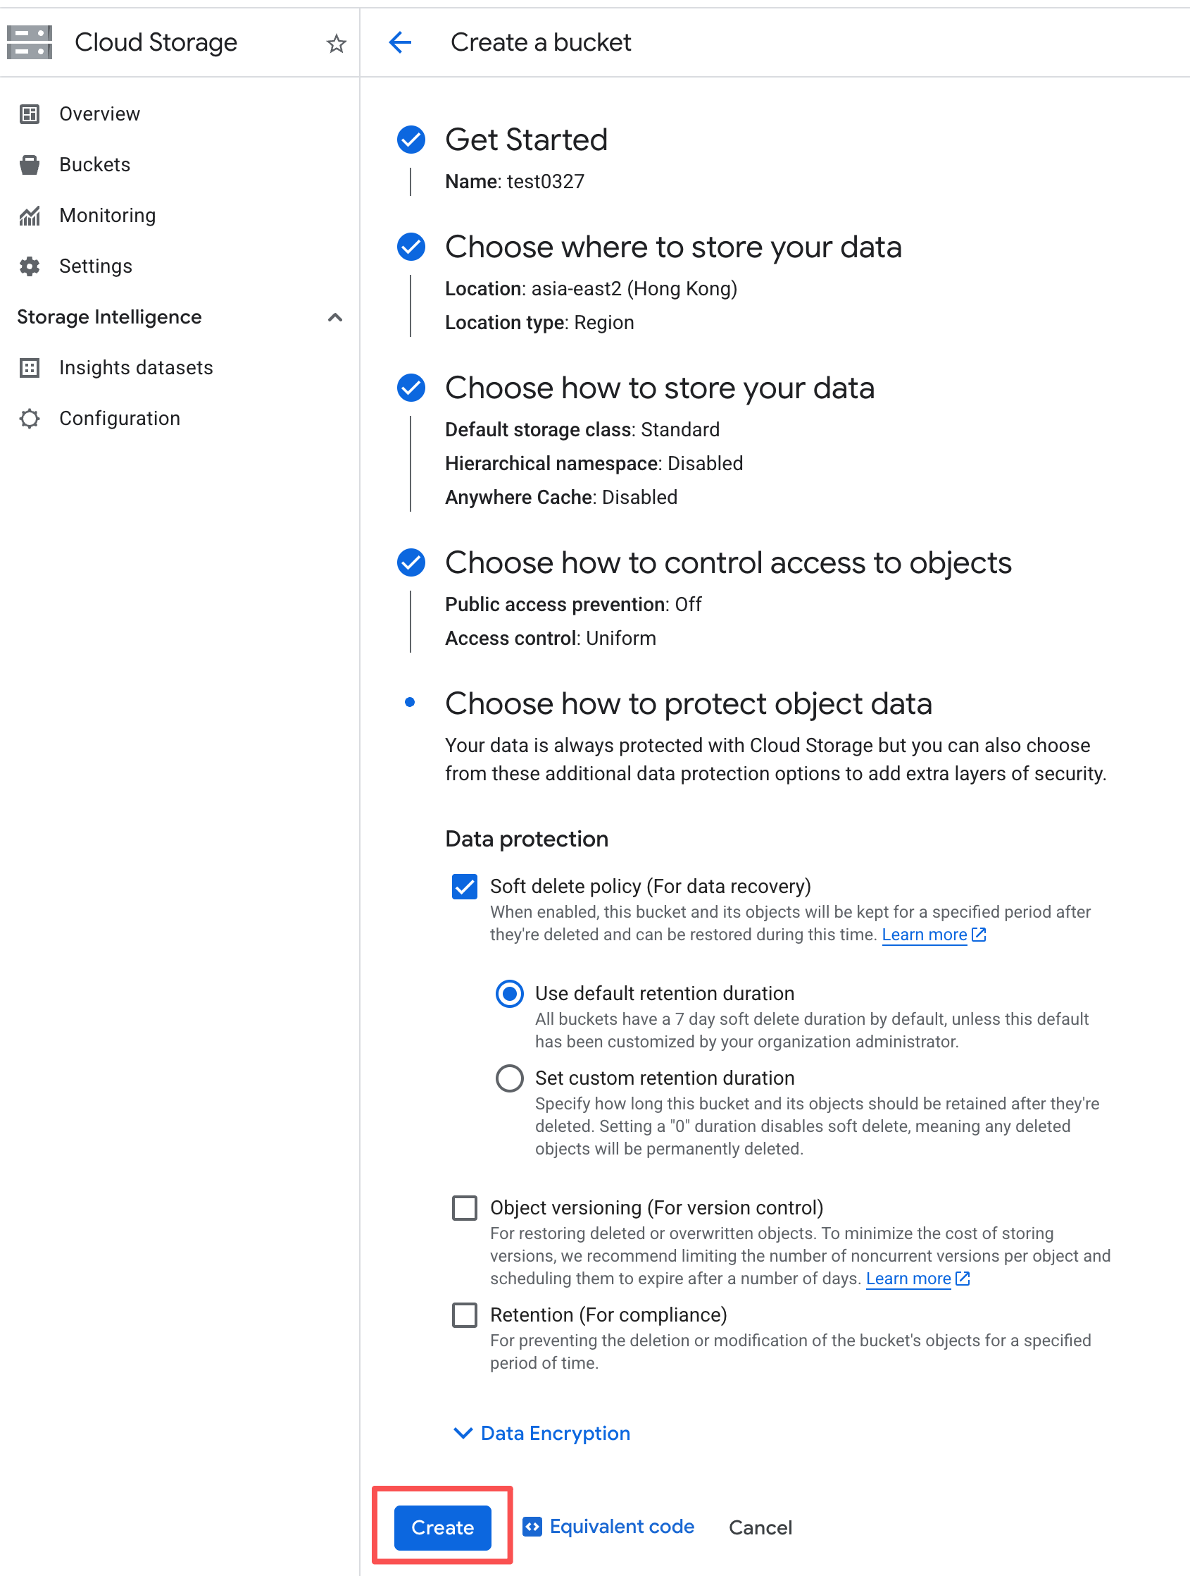 | 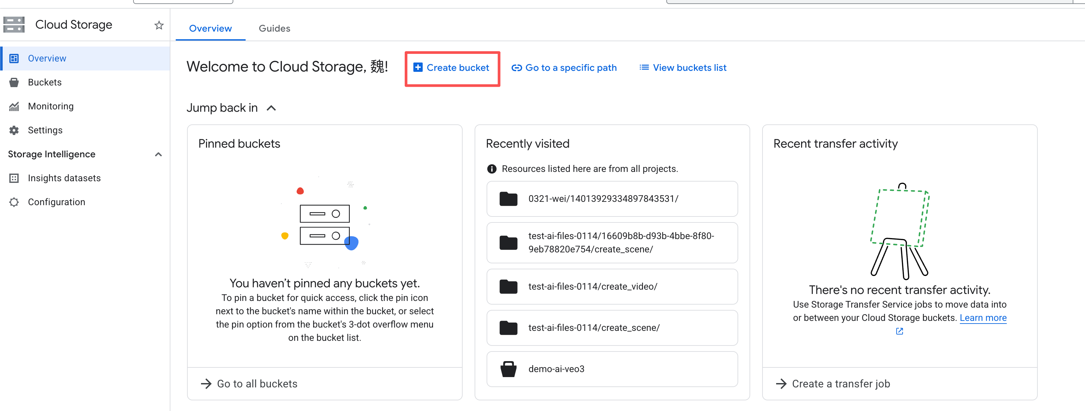
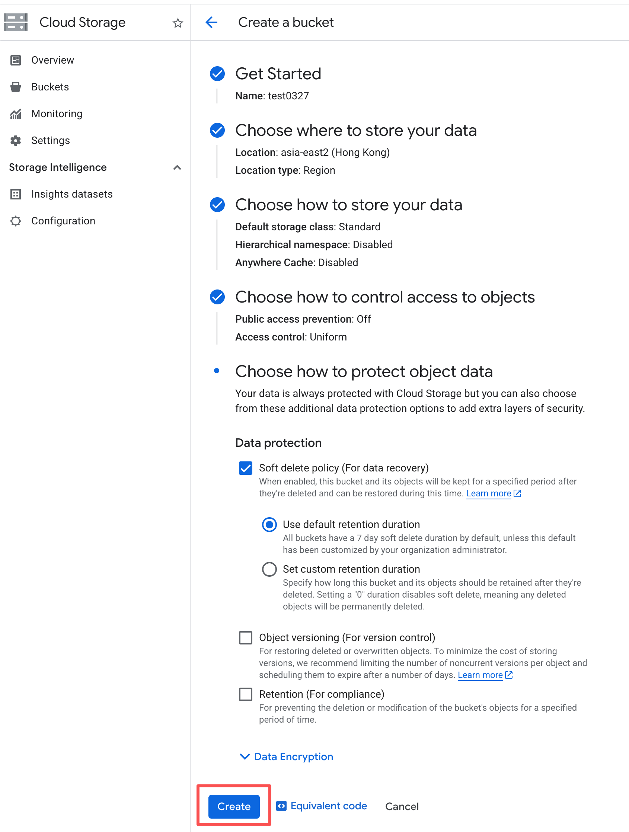

3.1 调用方式

3.1.1 Gen AI SDK

3.1.1.1 使用服务账号密钥认证
服务账号是 Google Cloud 标准的认证方式，通过 JSON 密钥文件进行身份验证，更安全且支持更广泛的模型（如 Anthropic Claude）。

3.1.1.1.1 创建并配置 Service Account

3.1.1.1.2 登录 GCP 控制台
https://console.cloud.google.com/（请使用授权的 Google 账号，不清楚可咨询销售经理）

3.1.1.1.3 选择分配的project
（不清楚的可咨询销售经理获取）


3.1.1.1.4 创建服务账号
进入服务账号界面（IAM 和管理），点击创建：
 | 

3.1.1.1.5 配置服务账号
服务账号 ID 自定义，权限给 Vertex AI User
 | 

3.1.1.1.6 创建服务账号密钥
点击创建的服务账号进入：
 | 

3.1.1.1.7 获取密钥文件（JSON）
点击创建后会跳出下载 json 界面，请妥善保管自己的密钥文件！
 | 

3.1.1.1.8 Python示例代码
Plain Text
pip install --upgrade google-genai

Python
import time
import sys
from google import genai
from google.genai import types
from google.oauth2 import service_account
# ====================================================================
# 1. 认证配置：在此处填写你的 service-account-key.json 文件的绝对或相对路径
# ====================================================================
SERVICE_ACCOUNT_FILE_PATH = "your-json-file-path" # 替换为你的文件路径
# 从 JSON 文件中读取并加载凭证
credentials = service_account.Credentials.from_service_account_file(
SERVICE_ACCOUNT_FILE_PATH,
scopes=["https://www.googleapis.com/auth/cloud-platform"] # Vertex AI 必须包含这个权限范围
)
# ====================================================================
# 2. 初始化客户端：传入加载好的凭证
# ====================================================================
client = genai.Client(
vertexai=True, # 明确指定使用 Vertex AI 后端
project="your-project-id", # 你的项目 ID
location="us-central1", # 资源所在区域
credentials=credentials # 传入读取到的文件凭证
)
# ====================================================================
# 3. 配置并调用视频生成模型
# ====================================================================
# 文生视频
source = types.GenerateVideosSource(
prompt="A futuristic cyberpunk city with flying cars at night", # 请在这里填入你的 prompt
)
# 图生视频
#source = types.GenerateVideosSource(
# prompt="""a car""",
# image=types.Image(
# image_bytes=b64decode("iVBORw0KGgXXXXXXXXU5ErkJggg=="),
# mime_type="image/png",
# ),
#)
config = types.GenerateVideosConfig(
aspect_ratio="16:9",
number_of_videos=1,
duration_seconds=8,
person_generation="allow_all",
generate_audio=True,
resolution="1080p",
output_gcs_uri="gs://0321-wei",
seed=0,
)
# 发送视频生成请求
print("Submitting video generation request...")
operation = client.models.generate_videos(
model="veo-3.1-generate-001",
source=source,
config=config
)
# ====================================================================
# 4. 轮询等待视频生成完成
# ====================================================================
while not operation.done:
print("Video has not been generated yet. Check again in 10 seconds...")
time.sleep(10)
operation = client.operations.get(operation)
response = operation.result
if not response:
print("Error occurred while generating video.")
sys.exit(1)
generated_videos = response.generated_videos
if not generated_videos:
print("No videos were generated.")
sys.exit(1)
# ====================================================================
# 5. 输出结果
# ====================================================================
print(operation.result)

SQL
视频生成返回结果，在gcs中可以找到这个视频。
Submitting video generation request...
Video has not been generated yet. Check again in 10 seconds...
Video has not been generated yet. Check again in 10 seconds...
Video has not been generated yet. Check again in 10 seconds...
Video has not been generated yet. Check again in 10 seconds...
Video has not been generated yet. Check again in 10 seconds...
Video has not been generated yet. Check again in 10 seconds...
Video has not been generated yet. Check again in 10 seconds...
Video has not been generated yet. Check again in 10 seconds...
Video has not been generated yet. Check again in 10 seconds...
Video has not been generated yet. Check again in 10 seconds...
Video has not been generated yet. Check again in 10 seconds...
Video has not been generated yet. Check again in 10 seconds...
Video has not been generated yet. Check again in 10 seconds...
Video has not been generated yet. Check again in 10 seconds...
Video has not been generated yet. Check again in 10 seconds...
generated_videos=[GeneratedVideo(
video=Video(
mime_type='video/mp4',
uri='gs://0321-wei/12470029429052131217/sample_0.mp4'
)
)] rai_media_filtered_count=0 rai_media_filtered_reasons=None

SQL
视频失败返回结果,多半是触发了安全问题导致的。
Submitting video generation request...
Video has not been generated yet. Check again in 10 seconds...
Video has not been generated yet. Check again in 10 seconds...
Video has not been generated yet. Check again in 10 seconds...
Video has not been generated yet. Check again in 10 seconds...
Video has not been generated yet. Check again in 10 seconds...
Video has not been generated yet. Check again in 10 seconds...
Video has not been generated yet. Check again in 10 seconds...
Video has not been generated yet. Check again in 10 seconds...
Video has not been generated yet. Check again in 10 seconds...
Video has not been generated yet. Check again in 10 seconds...
No videos were generated.

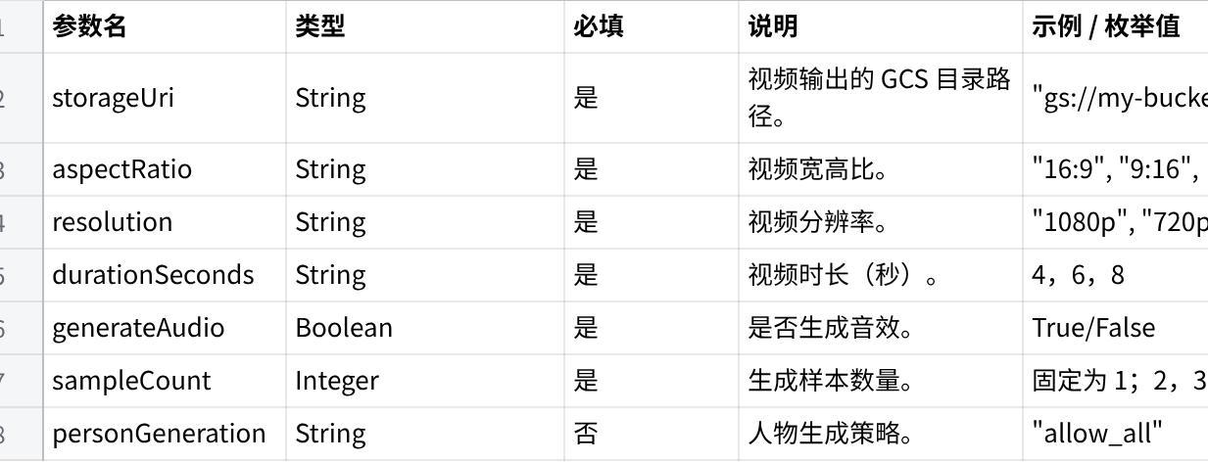
点击图片可查看完整电子表格

4. Embeddings 模型
- text-embedding-005
- text-multilingual-embedding-002
- gemini-embedding-001
以上模型支持选择任务类型，任务类型可以提高嵌入模型生成的嵌入的质量：
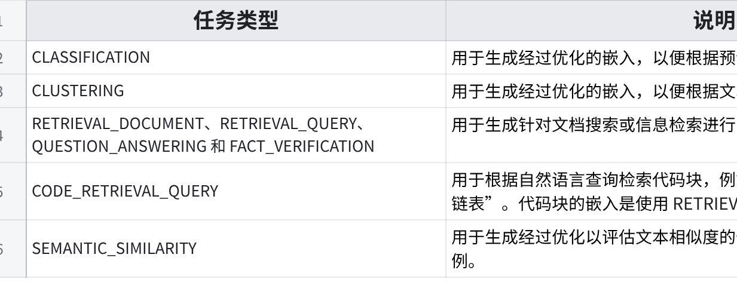
点击图片可查看完整电子表格

4.1 调用方式

4.1.1 REST 方式调用
服务账号的获取参考 1.1.2.1 章节

SQL
输出结果:
Generating embeddings via Vertex (gemini-embedding-001)...
Embeddings shape: (3, 3072)
First embedding (前20维): [-0.01268514 0.01737809 0.01978045 -0.09163763 0.01604444 0.0013196
0.01342789 -0.01695248 -0.00054076 0.01192953 -0.0025285 -0.02232655
-0.00296428 0.00100849 0.14814581 0.01676066 -0.01843566 0.00185798
-0.01083889 -0.0181412 ]
----------------------------------------

使用服务账号认证获取 token

Python
import requests
import numpy as np
from google.oauth2 import service_account
from google.auth.transport.requests import Request
# ========== 配置 ==========
PROJECT_ID = "your-projectid" #替换
LOCATION = "us-central1"
MODEL = "gemini-embedding-001"
SERVICE_ACCOUNT_FILE = "your-json-file-path"
API_URL = f"https://{LOCATION}-aiplatform.googleapis.com/v1/projects/{PROJECT_ID}/locations/{LOCATION}/publishers/google/models/{MODEL}:predict"
# ========== 获取 Access Token（等价 gcloud auth print-access-token） ==========
credentials = service_account.Credentials.from_service_account_file(
SERVICE_ACCOUNT_FILE,
scopes=["https://www.googleapis.com/auth/cloud-platform"],
)
credentials.refresh(Request())
ACCESS_TOKEN = credentials.token
HEADERS = {
"Authorization": f"Bearer {ACCESS_TOKEN}",
"Content-Type": "application/json; charset=utf-8",
}
# ========== Embedding ==========
def embed_texts(texts, task_type="RETRIEVAL_DOCUMENT"):
"""
texts: List[str]
task_type: RETRIEVAL_DOCUMENT / RETRIEVAL_QUERY / CODE_RETRIEVAL_QUERY / SEMANTIC_SIMILARITY
"""
payload = {
"instances": [
{
"content": text,
"task_type": task_type
}
for text in texts
],
"parameters": {
"autoTruncate": True
}
}
resp = requests.post(API_URL, headers=HEADERS, json=payload)
if resp.status_code != 200:
raise RuntimeError(f"Embedding API Error: {resp.status_code} {resp.text}")
result = resp.json()
embeddings = []
for pred in result["predictions"]:
vec = np.array(pred["embeddings"]["values"], dtype=np.float32)
# 归一化（推荐）
vec = vec / np.linalg.norm(vec)
embeddings.append(vec)
return np.array(embeddings)
# ========== Demo ==========
if __name__ == "__main__":
texts = [
"This is a test txt.",
"def add(a, b): return a + b",
"How does the brain work?"
]
print("Generating embeddings via Vertex (gemini-embedding-001)...")
embeddings = embed_texts(
texts,
task_type="RETRIEVAL_DOCUMENT"
)
print("Embeddings shape:", embeddings.shape)
print("First embedding (前20维):", embeddings[0][:20])

4.1.2 Vertex Python SDK 调用
安装依赖：
pip install google-cloud-aiplatform faiss-cpu numpy
服务账号的获取参考 1.1.2.1 章节

SQL
输出结果：
🔨 Building embeddings...
✅ Indexed 5 code snippets
🔍 Query: function to add two numbers
📊 Results:
Score: 0.7883
Code : def add(a, b): return a + b
----------------------------------------
Score: 0.6888
Code : def multiply(a, b): return a * b
----------------------------------------
Score: 0.6838
Code : def subtract(a, b): return a - b
----------------------------------------

Python
import numpy as np
import faiss
from vertexai.language_models import TextEmbeddingInput, TextEmbeddingModel
import vertexai
from google.oauth2 import service_account
# ========== 配置 ==========
PROJECT_ID = "your-projectid"
LOCATION = "us-central1"
MODEL_NAME = "gemini-embedding-001"
DIMENSION = 768 # 建议先用768（性能更好）
SERVICE_ACCOUNT_FILE = "your-json-file-path"
# 初始化 Vertex AI
vertexai.init(project=PROJECT_ID, location=LOCATION)
# 加载模型（只初始化一次）
model = TextEmbeddingModel.from_pretrained(MODEL_NAME)
# ========== 初始化认证 ==========
credentials = service_account.Credentials.from_service_account_file(
SERVICE_ACCOUNT_FILE
)
vertexai.init(
project=PROJECT_ID,
location=LOCATION,
credentials=credentials,
)
# ========== Embedding函数 ==========
def embed_texts(texts, task):
vectors = []
for text in texts:
inp = TextEmbeddingInput(text, task)
emb = model.get_embeddings([inp], output_dimensionality=DIMENSION)
vec = np.array(emb[0].values, dtype="float32")
# 归一化（关键！）
vec = vec / np.linalg.norm(vec)
vectors.append(vec)
return np.array(vectors)
# ========== 构建向量库 ==========
class CodeSearchEngine:
def __init__(self):
self.index = faiss.IndexFlatIP(DIMENSION) # 内积 = cosine（已归一化）
self.code_snippets = []
def build_index(self, code_list):
print("🔨 Building embeddings...")
vectors = embed_texts(code_list, task="RETRIEVAL_DOCUMENT")
self.index.add(vectors)
self.code_snippets = code_list
print(f"✅ Indexed {len(code_list)} code snippets")
def search(self, query, top_k=3):
print(f"\n🔍 Query: {query}")
query_vec = embed_texts([query], task="CODE_RETRIEVAL_QUERY")
scores, indices = self.index.search(query_vec, top_k)
results = []
for i, idx in enumerate(indices[0]):
results.append({
"score": float(scores[0][i]),
"code": self.code_snippets[idx]
})
return results
# ========== Demo ==========
if __name__ == "__main__":
engine = CodeSearchEngine()
# 模拟代码库
codebase = [
"def add(a, b): return a + b",
"def subtract(a, b): return a - b",
"def multiply(a, b): return a * b",
"def divide(a, b): return a / b",
"def distance(a, b): return (a**2 + b**2) ** 0.5",
]
# 构建索引
engine.build_index(codebase)
# 查询
query = "function to add two numbers"
results = engine.search(query)
print("\n📊 Results:")
for r in results:
print(f"Score: {r['score']:.4f}")
print(f"Code : {r['code']}")
print("-" * 40)

5. 参数详解

5.1 核心请求参数：
参数名 | 类型 | 描述
model | string | 模型名称，Vertex 上需带版本号（如 gemini-1.5-pro-002）
temperature | float | 控制随机性（0~2），值越低输出越确定，越高越有创意
maxOutputTokens | int | 生成的最大 token 数（输入+输出总和有上限）
topP | float | 核采样，概率累计阈值（通常与 temperature 二选一）
topK | int | 采样前考虑的 token 数量（Gemini 特有）
stopSequences | list | 停止词列表
safetySettings | list | 安全过滤配置（BLOCK_NONE, BLOCK_ONLY_HIGH 等）
thinkingBudget | int | 控制 Gemini 2.5 系列模型的思考 token 预算（0 表示关闭思考）

5.2 常用返回参数：
字段 | 描述
candidates | 生成的候选项列表，通常取第一个
candidates[0].content.parts[0].text | 生成的文本内容
candidates[0].finishReason | 停止原因（STOP, MAX_TOKENS, SAFETY 等）
usageMetadata.promptTokenCount | 输入消耗的 Token 数
usageMetadata.candidatesTokenCount | 输出消耗的 Token 数
usageMetadata.totalTokenCount | 总 Token 数

6. 报错排查

6.1 认证与权限相关错误
缺少有效凭证：
HTTP 状态码：401 Unauthorized
返回消息（示例）：
JSON
{
"error": {
"code": 401,
"message": "Request had invalid authentication credentials. Expected OAuth 2 access token, login cookie or other valid authentication credential.",
"status": "UNAUTHENTICATED"
}
}
原因：
- 未设置 GOOGLE_APPLICATION_CREDENTIALS 环境变量，或未执行 gcloud auth application-default login。
- 服务账号 JSON 文件路径错误或文件已损坏。
- 使用了错误的 API Key 或 API Key 未启用 Vertex AI 权限。

权限不足：
HTTP 状态码：403 Forbidden
返回消息（示例）：
JSON
{
"error": {
"code": 403,
"message": "Permission 'aiplatform.endpoints.predict' denied on resource 'projects/your-project/locations/us-central1/publishers/google/models/gemini-1.5-pro'",
"status": "PERMISSION_DENIED"
}
}
原因：
- 服务账号缺少 Vertex AI User 角色。
- 自定义 IAM 角色未授予 aiplatform.endpoints.predict 权限。

6.2 模型与区域相关错误
模型名称不存在：
HTTP 状态码：404 Not Found
返回消息（示例）：
JSON
{
"error": {
"code": 404,
"message": "Resource 'projects/your-project/locations/us-central1/publishers/google/models/gemini-2.0-flash' not found",
"status": "NOT_FOUND"
}
}
原因：
- 模型名称拼写错误或使用了不正确的版本号。
- 指定区域不支持该模型（例如 Claude 模型仅在部分区域可用）。

6.3 配额与限流错误
超出配额：
HTTP 状态码：429 Too Many Requests
返回消息（示例）：
JSON
{
"error": {
"code": 429,
"message": "Quota exceeded for aiplatform.googleapis.com/online_prediction_requests_per_minute_per_project. Limit: 60.0 in project 123456789012.",
"status": "RESOURCE_EXHAUSTED"
}
}
原因：
- paygo模式下，Gemini模型调用统一走Google动态共享资源池，根据Google的DSQ算法动态分配算力，在高峰期Google算力资源不足时会触发429报错。

6.4 请求参数与格式错误
输入内容过长：
HTTP 状态码：400 Bad Request
返回消息（示例）：
JSON
{
"error": {
"code": 400,
"message": "The input token count (128000) exceeds the maximum allowed token count (1048576) for this model.",
"status": "INVALID_ARGUMENT"
}
}
原因：
- 输入（prompt + 历史记录）总 Token 数超过了模型上下文窗口限制。

无效的 generation 参数：
HTTP 状态码：400 Bad Request
返回消息（示例）：
JSON
{
"error": {
"code": 400,
"message": "Invalid value at 'generation_config.temperature' (type.googleapis.com/google.protobuf.FloatValue), field value 2.5 is out of range [0.0, 2.0].",
"status": "INVALID_ARGUMENT"
}
}
原因：
- 传递了超出模型允许范围的参数（如 temperature 超出 0~2）。
- 使用了模型不支持的参数（如 top_k 在某些模型版本中不可用）。

6.5 安全与内容过滤错误
内容被安全过滤器拦截：
JSON
{
"candidates": [
{
"finishReason": "SAFETY",
"safetyRatings": [
{
"category": "HARM_CATEGORY_HATE_SPEECH",
"probability": "HIGH",
"blocked": true
}
]
}
]
}
原因：
- 输入或输出触发了 Google 的安全过滤器（仇恨言论、骚扰、色情等）。

6.6 网络与超时错误
请求超时：
HTTP 状态码：504 Gateway Timeout
返回消息（示例）：
JSON
{
"error": {
"code": 504,
"message": "Deadline exceeded.",
"status": "DEADLINE_EXCEEDED"
}
}
原因：
- 模型处理时间超过了客户端设置的超时时间（默认约 60 秒）。
- 输入过长或模型负载过高导致响应缓慢。

6.7 批量调用（Batch API）相关错误

输入文件格式错误
错误消息（在 BatchPredictionJob 日志中）：
Shell
Invalid JSONL line: {"content": "..."}
原因：
- JSONL 文件不符合 Vertex AI 要求的格式（例如缺少 content 字段，或使用了错误的 MIME 类型）。

